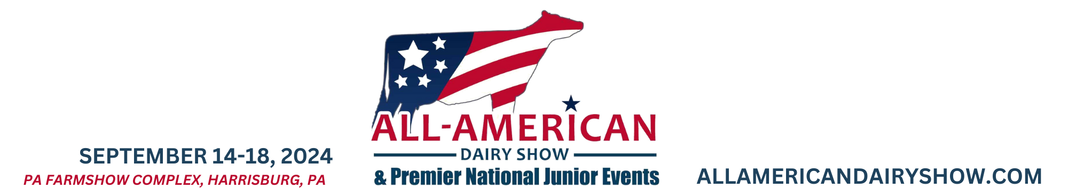

Virginia and Maryland Youth Recognized at Premier National Junior Show Celebrating the Dedication and Passion of Youth in the Dairy Industry
Harrisburg, Pa. (October 9, 2024) – Two young individuals were honored for their hard work and dedication during the Premier National Junior Show on Monday, Sept. 16. The Arthur W. Nesbitt Scholarship was awarded to Regan Jackson of Boyce, Va., and the Robert D. Heilman Youth Achievement Award went to Jillian Sutton of Westminster, Md. Both awards are presented by the All-American Dairy Foundation (AADF), a charitable educational organization dedicated to the dairy youth of the All-American Dairy Show.
The Arthur W. Nesbitt Scholarship is given in honor of the former executive secretary of the Pennsylvania Holstein Association and chief executive officer of NASCO, Inc. The scholarship is personally funded by Art Nesbitt. This year, at its annual meeting, the All-American Dairy Foundation Board of Trustees voted to match his contribution, increasing the scholarship amount to $2,000.
“I am deeply honored to receive the 2024 Arthur Nesbitt Scholarship,” Regan said. “For years, I have heard about this remarkable man who played an integral role in our nation’s dairy industry. He served many dairy organizations and is admired by so many. Receiving a scholarship in his name means the world to me and motivates me to make him, and the entire industry, proud as I continue my education. I hope to give back to the industry that has supported me so much along the way.”
Regan is the daughter of Kevin and Laura Jackson. She is a past recipient of the Robert D. Heilman Award at the Premier National Dairy Show. Currently, she is studying pre-med at Louisiana State University with an emphasis on human nutrition. She believes that the dairy industry needs more advocates in the medical field to promote the benefits of dairy products.
The Robert D. Heilman Youth Achievement Award recognizes outstanding youth passionate about the dairy industry who work hard, help others, and maintain a positive attitude regardless of the circumstances. The foundation seeks to honor youth who may not always be in the spotlight but who value the overall experience and continuously strive for improvement.
“Jillian is one of the hardest-working people I know. She can work for hours at a cow show and never complain,” said Ryan Haines, who is familiar with her work ethic. “She’s so even-keeled that many people may not notice her, but her diligence and effort make working with her a true pleasure. She is always willing to help others, especially younger exhibitors.”
Jillian Sutton is the daughter of Jeff Sutton and Kate Hall. She received a $500 check and a plaque in honor of Robert D. Heilman, the first executive director of the All-American Dairy Foundation. Although she has a small herd, she is dedicated to breeding quality cows capable of competing in the Premier National Junior Show. She has also participated in youth showmanship and the dairy judging contest.
"The All-American Dairy Foundation is proud to recognize the exceptional young individuals, like Regan and Jillian, " said AADF Foundation president, John Howard of Willow Street, Pa. “We are honored to support their future endeavors and celebrate their contributions to the industry."
In addition to these awards, the AADF provides grants to the Premier National Junior Dairy Show, judging and showmanship contests, Penn State and Delaware Valley scholarships and other dairy youth activities. Donations are tax-deductible and can be made payable to the All-American Dairy Foundation and mailed to 1021 Pfoutz Valley Road, Millerstown, PA 17062. For more information, visit AllAmericanDairyFoundation.com.
###

Photos and captions (high-resolution photos attached):

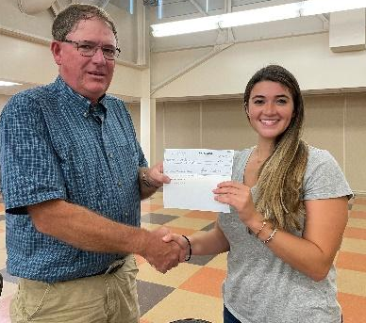

James Osborne, D.V.M., All-American Dairy Foundation executive director from Millerstown, Pa., presents the Arthur W. Nesbitt Scholarship to Regan Jackson from Boyce, Va.

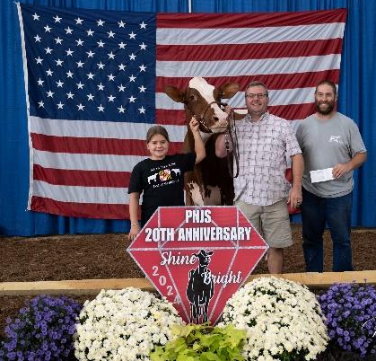

Jeremy Daubert, All-American Dairy Foundation board member from Dayton, Va., right, presents the Robert D. Heilman Youth Achievement Award to Jillian Sutton’s father Jeff and sister Lucy. They are pictured with Jillian’s cow that placed first in the Red and White Holstein Senior 2-Year-Old Class of the Premier National Junior Dairy Show.

